iSecurity Platform

1

把地球页面设置为主题页面，点击主题页面后跳转为我目前所创的homepage。

地球整体背景调整为和homepage一致的蓝色，具体请参考homepage。

地球上的文字是:

Welcome to the iSecurity e-Learning Platform！

The University of Hong Kong

Faculty of Education

Zian Lu

具体跳转顺序：先是单纯的地球，地球周边环绕Security Need, Personal Security, Enterprise Security。然后点击文字，随后跳转到homepage。

2

在homepage右下角设置问答机器人，点击机器人后出现问答弹框。

机器人头像：



机器人的名字叫Security Bot。

User：Hello

Security Bot：Hi! Welcome to the iSecurity Platform. May I help you?

User: Where are the training games and learning materials?

Security Bot; The training games and learning materials can be found under the resources section.

User: Where can I take the lessons?

Security Bot: The lessons can be taken under the activities section.

User: Go to the support page.

Security Bot: Here is the link.

User: Go to the feedback page.

Security Bot: Here is the link.

User: What is information security?

Security Bot: Information security is the act of protecting digital information assets.

User: What is ransomware?

Security Bot: Ransomware is malicious software that encrypts data on a computer until a sum of money is paid to the hacker.

User: What is my score of lesson 1?

Security Bot: 提供真实答题数据。

User: What is my score of lesson 2?

Security Bot: 提供真实答题数据。

User: What is my score of lesson 3？

Security Bot: 提供正式答题数据。

3

设置Login页面。

User可以简单创建用户名和密码。

创建用户名后，测试成绩需要与用户名匹配。

4

设计Learning Analytics页面。

|  |  |  |  |  |
| --- | --- | --- | --- | --- |
| User | Lesson 1 | Lesson 2 | Lesson 3 | Sum |
| 1 |  |  |  |  |
| 2 |  |  |  |  |
| 3 |  |  |  |  |
| 4 |  |  |  |  |
| 5 |  |  |  |  |

在页面下方插入统计图，分析user的成绩变化。

5

设置Contact Information Page。

Contact Information

Thank you for choosing iSecurity Platform as your learning and training website! For all your concerns and inquiries, please contact our reception hot line 24 hours a day and 7 days a week: +86 13906513176.

|  |  |
| --- | --- |
| Map/Satellite  The University of Hong Kong  The Faculty of Education | Contact Us via Email |
| First Name: |
| Last Name: |
| Email: |
| Subject: |
| Message: |

Submit

6

设置Forum Page。

Forum

Thank for joining the forum of iSecurity Platform! Here you can create engaging conversations with your fellow learners and sharing knowledge with others.

Welcoming Post

Here you can learn about the functions of the forum.

Rules & Regulations

Here you can learn about the rules and regulations of the forum

Self-Introduction

Here you can introduce yourselves to others fellow learners.

Questions & Answers

Here you can generate questions, get answers and share your knowledge.

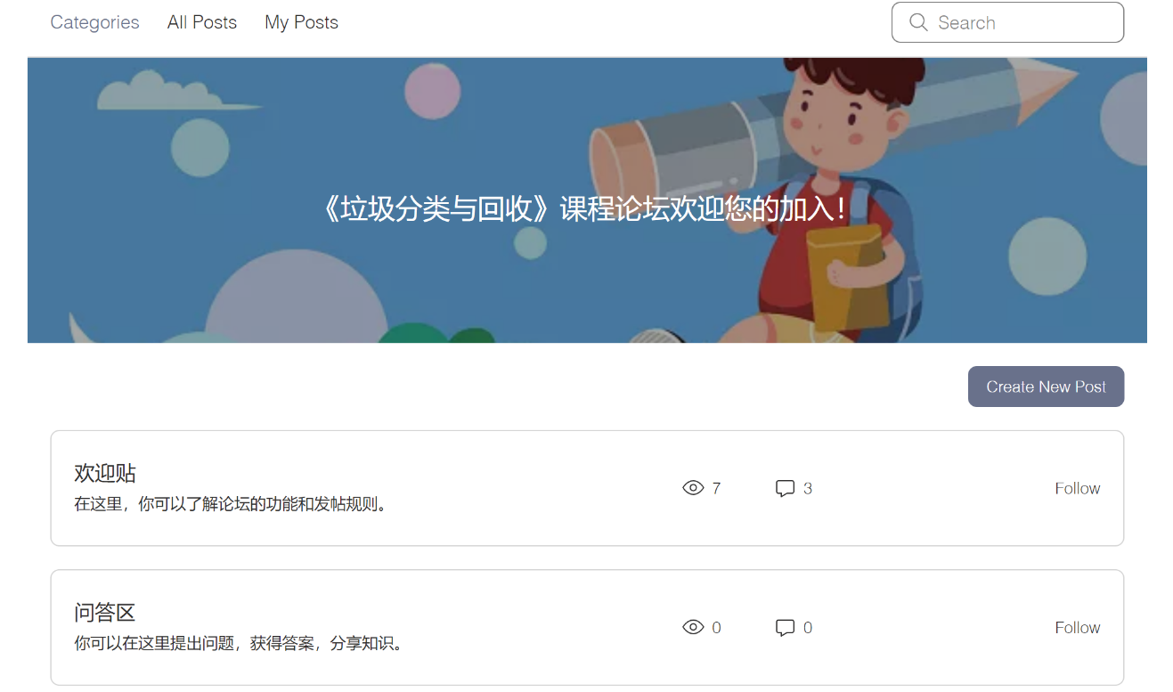

各大标题也需用此文字。

Welcoming Post

Here you can learn about the functions of the forum.

Rules & Regulations

Here you can learn about the rules and regulations of the forum

Self-Introduction

Here you can introduce yourselves to others fellow learners.

Questions & Answers

Here you can generate questions, get answers and share your knowledge.

Welcome to the Welcoming Post!

Dear learners:

Hi!

Welcome to the discussion forum, the course forum for the development and design of the “iSecurity e-Learning Platform”.

This forum can provide you with a space to share your learning process. During the course study, you can share your learning process and interesting ideas with other students in the forum.

The forum will provide a channel for solving common problems. While you are engaging and exploring the course activities, you might face some problems regarding information security. Here you can post your questions and get help from other learners. At the same time, you can also answer questions posted by other learners.

In addition, the forum will regularly share some articles about information security, and you can welcome to participate in learning and make constructive comments!

Let’s join the course together!

The Design and Development Team

The University of Hong Kong

Welcome to the Rules & Regulations!

Dear learners:

Hi!

I hope every student can enjoy and benefit from the forum. Therefore, I think it is necessary that everyone can read and abide by the following rules of the forum:

1. Respect each other and maintain a harmonious and civilized environment for the benefits of the forum.
2. Make sure that the artivle conforms to the theme of the forum, and do not post any articles or messages indiscriminately.
3. Actively participate in the forum questions & answers and interact others with a responsible manner.

Let’s join the course together!

The Design and Development Team

The University of Hong Kong

Welcome to the Self-Introduction!

Dear learners:

Hi!

Please welcome each other and spend some time to introduce yourselves to the community by posting a comment!

Let’s join the course together!

The Design and Development Team

The University of Hong Kong

Welcome to the Questions & Answers!

Dear learners:

Hi!

Here you can post your questions and receive clarifications from other learners. At the same time, you can also answer questions posted by other learners.

Let’s join the course together!

The Design and Development Team

The University of Hong Kong

